DEALS TO FORT WORTH

Just west of Dallas, the Fort Worth area has a distinct culture and flavor all its own. The “City of Cowboys and Culture” offers visitors a vast array of wonderful experiences, including a rich arts scene and culinary treats that will please even the pickiest palates. Book a trip to Fort Worth via Dallas Love Field on Virgin America. Live it up at 35,000 feet with WiFi, on-demand entertainment, and more on every flight.

(MARKET IMAGE HERE)

Find Deals From These Cities

INSERT FARE GRID FROM / TO Version (if available!)

   
Top Things To Do in Fort Worth

Below are just a few of the many great things to do in Fort Worth.

* Take a leisurely outing to the Sundance Square Plaza. You’ll enjoy people watching, grabbing a bite to eat on the patio, and seeing the relaxing water fountains.
* Tour the Fort Worth Stockyards Historic District. Witness a daily cattle drive and eat cowboy cuisine at one of the many restaurants in this historic neighborhood. Go on a Friday or Saturday night for the Championship Rodeo or for some dancing (or both).
* Get up close with cheetahs, flamingos, and many more animals when visiting them in their home at the Fort Worth Zoo. While there, stop by Texas Town, a model Wild West Village.
* See one of the world’s top small museums. The Kimbell Art Museum has a diverse permanent collection that includes works featuring famous artists such as Rembrandt, Picasso, and Monet. Even the facility itself is an impressive work of art!

Travel Tips and Resources

[Must-Dos in Fort Worth](http://www.tripadvisor.com/Attractions-g55857-Activities-Fort_Worth_Texas.html)

[Fort Worth Hotels](http://www.tripadvisor.com/Hotels-g55857-Fort_Worth_Texas-Hotels.html)

[Fort Worth Restaurantshttp://www.movoto.com/blog/opinions/fort-worth-restaurants/](http://www.movoto.com/blog/opinions/fort-worth-restaurants/)

[Fort Worth Shopping Guidehttp://www.fortworth.com/things-to-do/shopping](http://www.fortworth.com/things-to-do/shopping)

[Fort Worth Nightlife and Entertainmenthttp://www.fortworth.com/things-to-do/nightlife](http://www.fortworth.com/things-to-do/nightlife)

[Fort Worth Travel Tipshttp://www.fodors.com/world/north-america/usa/texas/dallas-fort-worth/travel-tips](http://www.fodors.com/world/north-america/usa/texas/dallas-fort-worth/travel-tips)

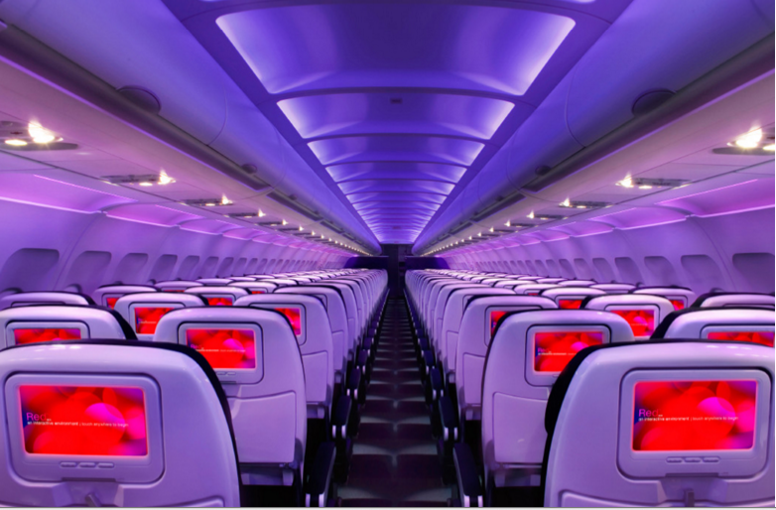

Main Cabin Main Cabin Select First Class

(add links to Cabin Class Pages)

Ready. Set. Fly.

Book your Mood-lit Ride to Fort Worth.

If you’re looking into flights to Fort Worth, fly with Virgin America to enjoy a pleasant and relaxing in-flight experience. You’ll fly into Dallas Love Field (DAL), which is conveniently located just minutes outside of Fort Worth. We offer the most comfortable leather seats, soothing mood-lit cabins, and a variety of on-demand entertainment options in order to ensure you have the best flight experience possible.

Take a Virtual Tour

Add Terms & Conditions